

Computer Graphics

3D _Project 2



toqa tarek

20102364

The Idea:

On a roadway that is rumoured to be haunted by spirits, the scene depicts an automobile travelling down it at night, in the pitch blackness and bitter cold. A ball was rolling along the bridge adjacent to the haunted home as you were walking, but then it disappeared, startling the driver, who sped the car home.

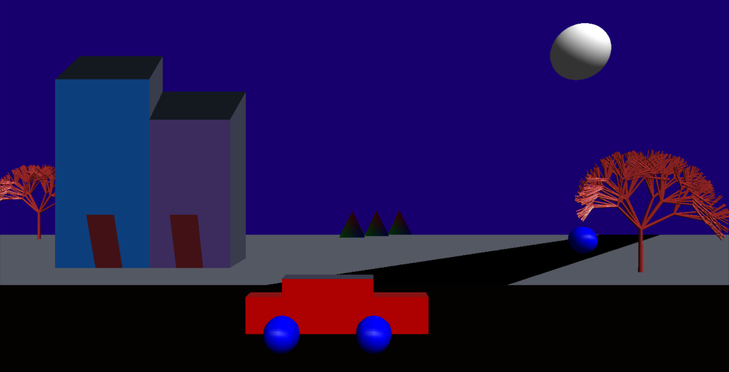The final output result: